Growing Together Montana 2022 Press Toolkit
About Growing Together Montana
Growing Together Montana is an exciting grant opportunity for Master Gardeners! This project is a partnership between the MSU Extension Nutrition Education program and the Master Gardener program. The goal of the project is for Master Gardeners to grow produce to donate to local food banks, and work with the MSU SNAP-Ed program to provide nutrition education. Grants are being offered in amounts up to $2,000 to start, reinvigorate, or maintain a donation garden.
How to Use This Press Toolkit
The purpose of this toolkit is to give you easy ways to promote the Growing Together Montana project. We’ve done all the hard work for you! All you’ll need to do is copy and paste these drafts into a social media post, email, newsletter, etc. We have also provided a variety of thumbnail images (below) that you can use if you choose to. The photos provided can be saved as an image and attached to a social media post or inserted in the body of an email or newsletter. A promotional poster can also be found on our website and can be printed or attached to an email.
Social Media Post Draft
“Announcing an exciting grant opportunity for Master Gardeners! The Growing Together Montana grant project is a partnership between the MSU Extension Nutrition Education Program and the Master Gardener program that focuses on growing produce to donate to local food banks. Time spent on this project will also count toward Master Gardener volunteer hours. Grant applications will be due by February 11th, 2022. Follow the link to learn more and apply!” https://buyeatlivebetter.org/growing_together_montana.html
Or-
“Are you a Master Gardener looking for a way to make a difference in your community? The Growing Together Montana project provides grants to Master Gardeners who want to start, maintain, or reinvigorate a donation garden and provide fresh produce to local food banks. Time spent on this project will also count toward Master Gardener volunteer hours. Grant applications are due by February 11th, 2022. Follow the link to learn more and apply!” https://buyeatlivebetter.org/growing_together_montana.html
Email Draft
Subject: Grant Opportunity for Master Gardeners
“We are pleased to announce an exciting grant opportunity for Master Gardeners! The Growing Together Montana (GTMT) grant project is a partnership between the MSU Extension Nutrition Education Program and the Master Gardener program that focuses on growing produce to donate to local food banks.
Grants are being offered in amounts up to $2,000 and can be used to start, reinvigorate, or maintain a donation garden. Grant recipients will also have the opportunity to work with the MSU SNAP-Ed program to provide basic nutrition education to individuals and families being served by local food banks. Time spent on this project will also count toward Master Gardener volunteer hours. GTMT grant applications will be due by February 11th, 2022.
Take a look at the Growing Together Montana website to learn more!
Have questions or know of a Master Gardener that may be interested? Feel free to reach out to Dara Palmer by phone 406-994-2120 or by email dara.palmer@montana.edu.”
Newsletter Announcement Draft
Heading: Grant Opportunity for Master Gardeners
We are pleased to announce an exciting grant opportunity for Master Gardeners! The Growing Together Montana (GTMT) grant project is a partnership between the MSU Extension Nutrition Education Program and the Master Gardener program that focuses on growing produce to donate to local food banks.
Grants are being offered in amounts up to $2,000 and can be used to start, reinvigorate, or maintain a donation garden. Grant recipients will also have the opportunity to work with the MSU SNAP-Ed program to provide basic nutrition education to individuals and families being served by local food banks. Time spent on this project will also count toward Master Gardener volunteer hours. GTMT grant applications will be due by February 11th, 2022.
Take a look at the Growing Together Montana website to learn more!
Have questions or know of a Master Gardener that may be interested? Feel free to reach out to Dara Palmer by phone 406-994-2120 or by email dara.palmer@montana.edu.”
Have Questions?
Feel free to reach out to Dara Palmer with any questions you may have! You can also direct interested Master Gardener’s to Dara and she would be happy to discuss this grant opportunity with them. She can be reached at 406-994-2120 or dara.palmer@montana.edu.

Growing Together Montana Thumbnail Images for Social Media Posts
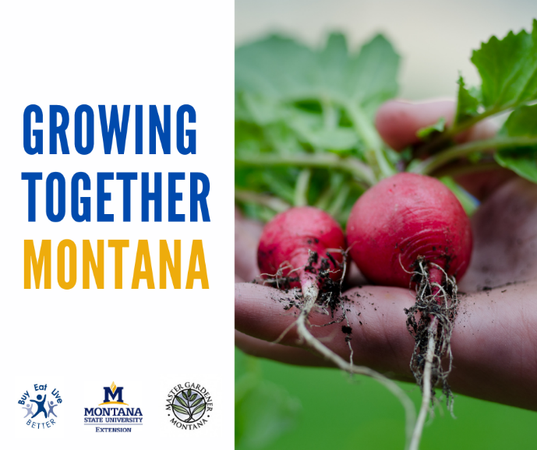
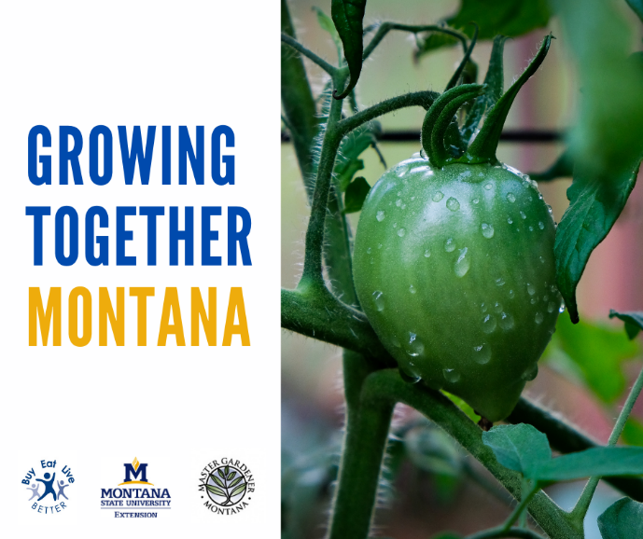
Simply right click the images that you would like to attach to a social media post, email, newsletter, etc. and select “Save As” to save them to your desktop or folder of your choosing.
